**Value Types vs Reference Types & Functions Pass by Ref:**

Value Type:

A data type is a value type if it holds a data value within its own memory space. It means variables of these data types directly contain their values.

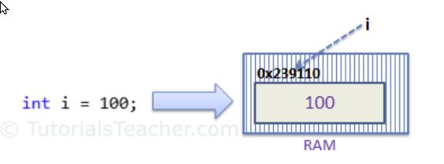

Reference Type:

Unlike value types, a reference type doesn't store its value directly. Instead, it stores the address where the value is being stored. In other words, a reference type contains a pointer to another memory location that holds the data.

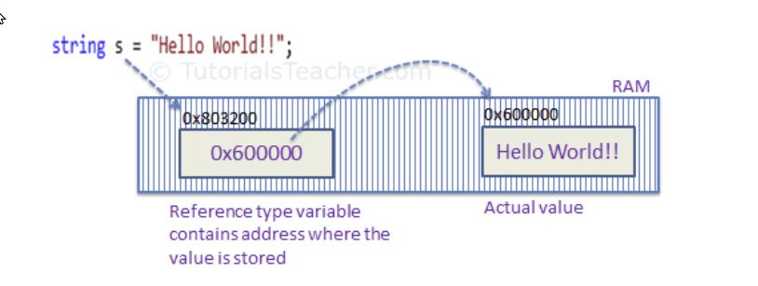

**Functions: Passing By Reference or Passing By Value**

When you pass a value type variable from one method to another method, the system creates a separate copy of a variable in another method, so that if value got changed in the one method won't affect on the variable in another method.

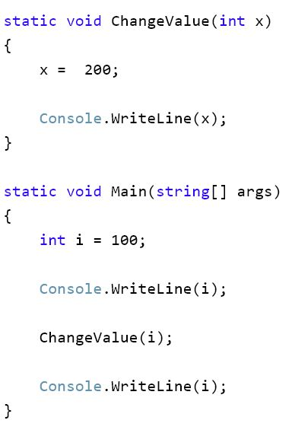

//100

//200

//100 (see how variable “i” didn’t get changed to 200).

When you pass by reference, you are sending the only copy of that reference (essentially an object pointer) variable.

**Stacks Vs Heaps:**

A Stack

